WordFinderApp User Manual

Table of Contents

- Introduction

- System Requirements

- Installation Instructions

- User Interface Overview

- Using WordFinderApp

- Troubleshooting

- Contacting Support

Introduction
Welcome to the user manual for WordFinderApp! This document is intended to provide you with all the information you need to get started with and use the software effectively.
System Requirements
Before installing WordFinderApp, please make sure your computer meets the following requirements:
Operating system: Windows 10 or superior
Processor: 1 gigahertz (GHz) or faster processor or SoC.
RAM: 1 gigabyte (GB) for 32-bit or 2 GB for 64-bit.
Hard disk space: 1 megabyte (MB).
Installation Instructions
To install WordFinderApp, please follow these steps:

- Copy setup.exe or WordFinderSetup.msi to your machine
- Execute the installer
- Follow the easy steps one by one by the wizard
- Congratulation, now you have WordFinderApp in you machine

User Interface Overview
The WordFinderApp user interface is designed to be intuitive and easy to use. Here's a brief overview of the different parts of the interface:
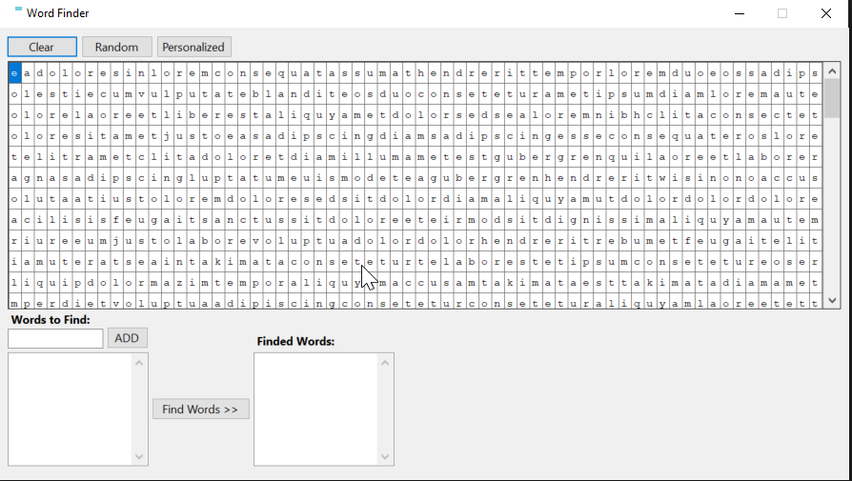
Using WordFinderApp
To use WordFinderApp, please follow these steps:
The grid for the matrix

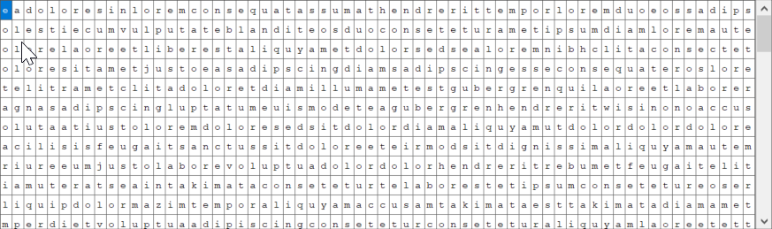
This grid is used to show the matrix where the words are going to be looked for. Here you are abble to clear the matrix, generate a random matrix or personalize the matrix.

For clear the matrix, just press the Clear botton

For generate a random matrix, just press the Random bottton
For personalize the matrix, follow this steps:

- Press the Personalized botton
- The InputBoxMultiline windows is going to be show:

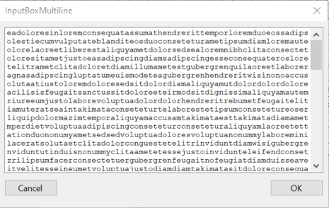

- Edit the matrix to your needs. You could even clear all and start over a clean matrix. The matrix must be 64x64.
- Click the OK botton
- The new personalized matrix is shown on the grid.

The words to find list
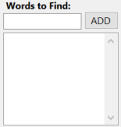

For add a new word to the find list, follow this steps:

- Write a new word.
- Press enter key or clic on the ADD botton
- The new word is shown in the list.
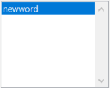

For remove a word from the list, just dobble clic on the word to be removed.

The finded words list
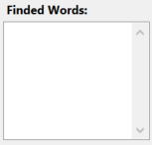

This list is used to show the top 10 finded word in the matrix.

Look for the words

To searches the matrix to look for the words from the words to find list, just clic on the Find Words » botton
Followed rules to search at the matrix:

- Words may appear horizontally, from left to right, or vertically, from top to bottom
- If any word in the words to find list is found more than one within the matrix, the search results count it only once
- The search will return the top 10 most repeated words from the words to find list
Troubleshooting
If you encounter any issues while using WordFinderApp, please contact support (see next section).
Contacting Support
If you need further assistance with WordFinderApp, please contact our support team at amd.guizmo@gmail.com.

